**A1.**

**Code:**

**Output**:

**A2**

**Code:**

**Output:**

**B1.**

**Code:**

**Output:**

**B2.**

**Code:**

**Output:**

C1

Code:

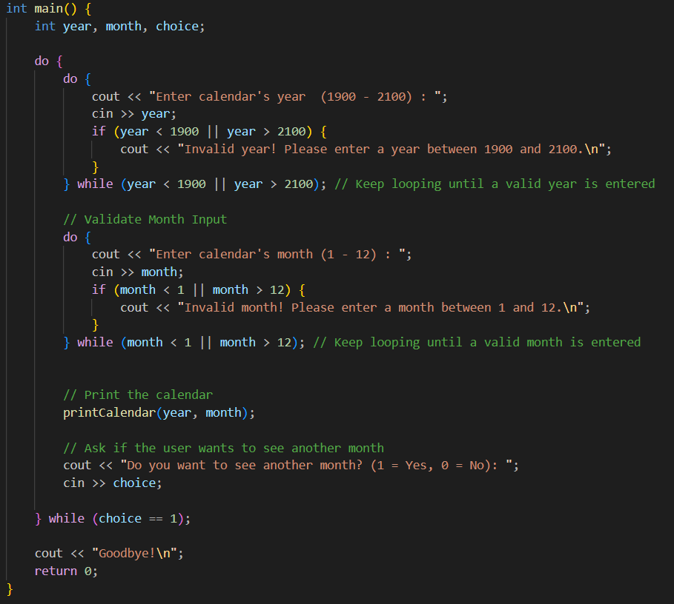

Output:

C2

Code:

Output:

C3

Code:

Output:

C4

Code:

Output:

C5

Code:

Output:

C6

Code:

Output:

C7

Code:

Output:

C8

Code:

Output:

